4. Understand linux utility commands like - ping, arp (Understand each params from ifconfig output)

Pinging google.com with specific packet count, interval, and packet size

**ping -c 4 -i 0.5 -s 64 google.com**

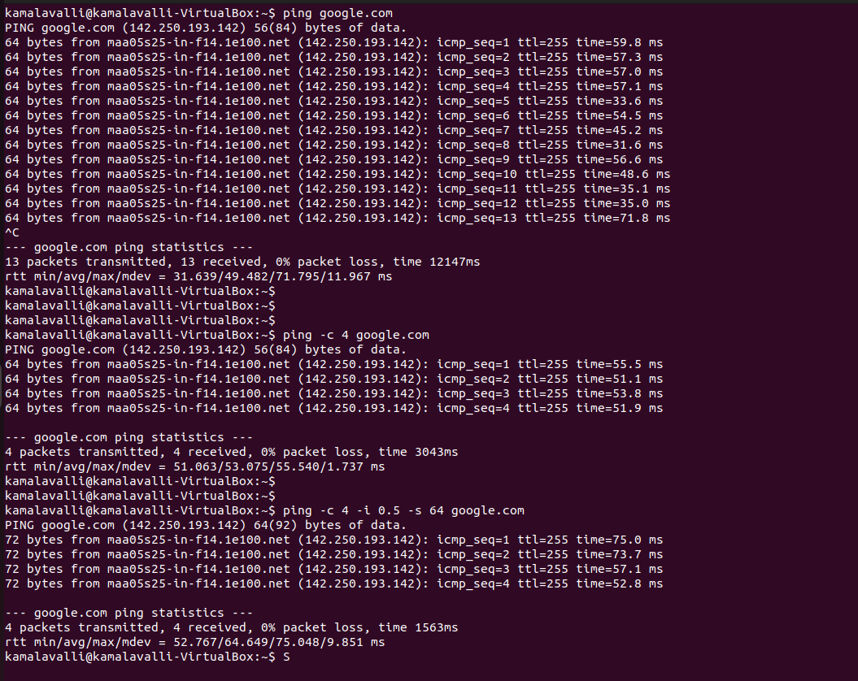

ARP:

**arp -a** - Displays the ARP table with hostnames (resolves IP addresses to hostnames if possible).

**arp -n** - Displays the ARP table without resolving hostnames (shows only numeric IP addresses).

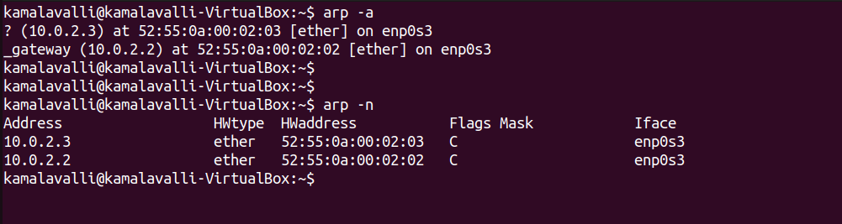

IFCONFIG:

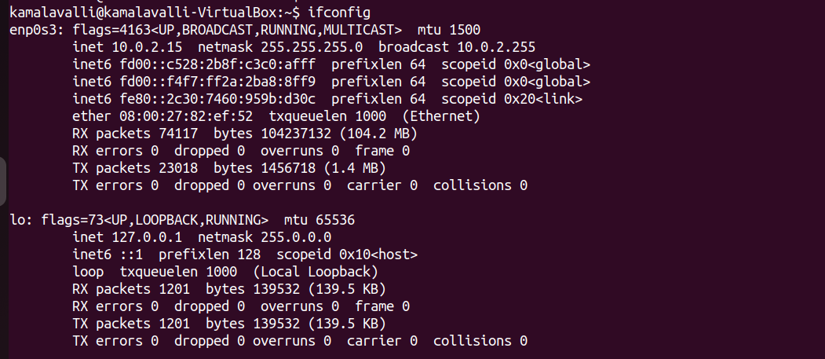

Ifconfig – params:

* **Interface Name** (enp0s3, lo)
* **Flags** (UP, BROADCAST, RUNNING, MULTICAST, LOOPBACK)
* **MTU** (1500 for enp0s3, 65536 for lo)
* **IPv4 Address** (inet 10.0.2.15, inet 127.0.0.1)
* **Subnet Mask** (netmask 255.255.255.0, 255.0.0.0)
* **Broadcast Address** (broadcast 10.0.2.255)
* **IPv6 Address** (inet6 fd00::c528:2b8f:c3c0:afff, etc.)
* **MAC Address** (08:00:27:82:ef:52)
* **TX and RX Packets** (RX packets, TX packets)
* **Errors, Drops, Overruns, Collisions** (RX errors, TX errors, dropped, overruns, collisions)